SPONSOR AN MCR PET
- 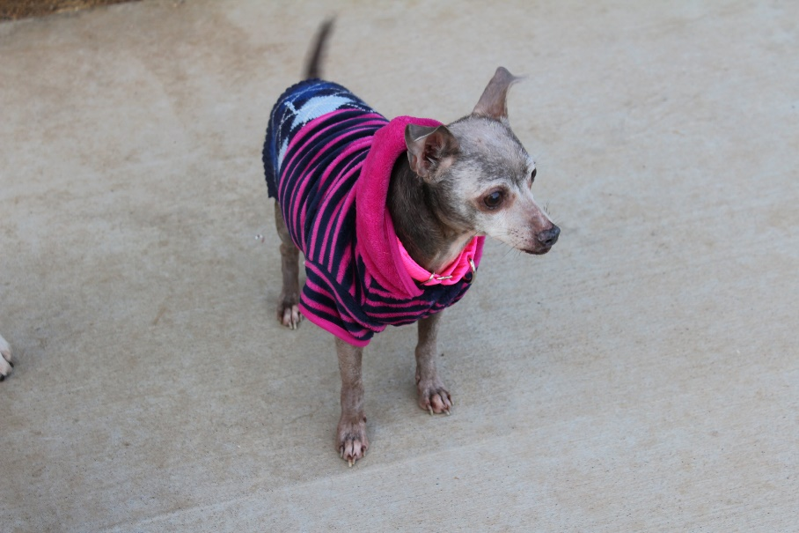
Blue. From SLO Animal Services, came to MCR Jan '17 and lived just a few weeks. Died at the El Camino vet hospital 1/25/17 after surgery. Sweet little ancient man

- 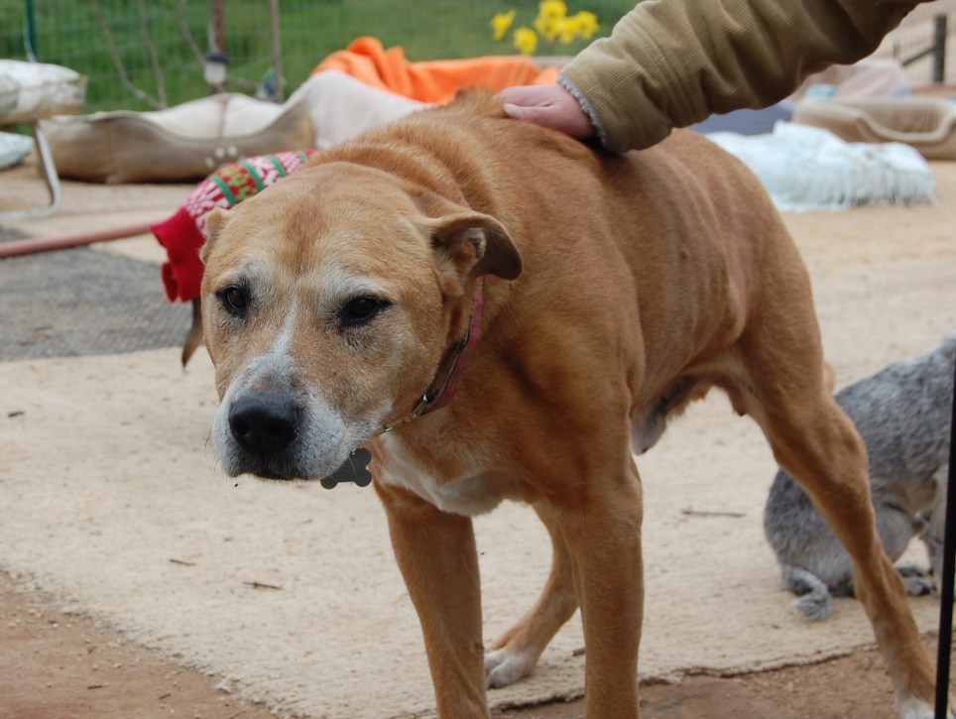
Mike. "Best dog in the whole world. An old man with a sad story... He deserves to be remembered!! Came to MCR from the area, dumped and left to die by the riverbed."

- 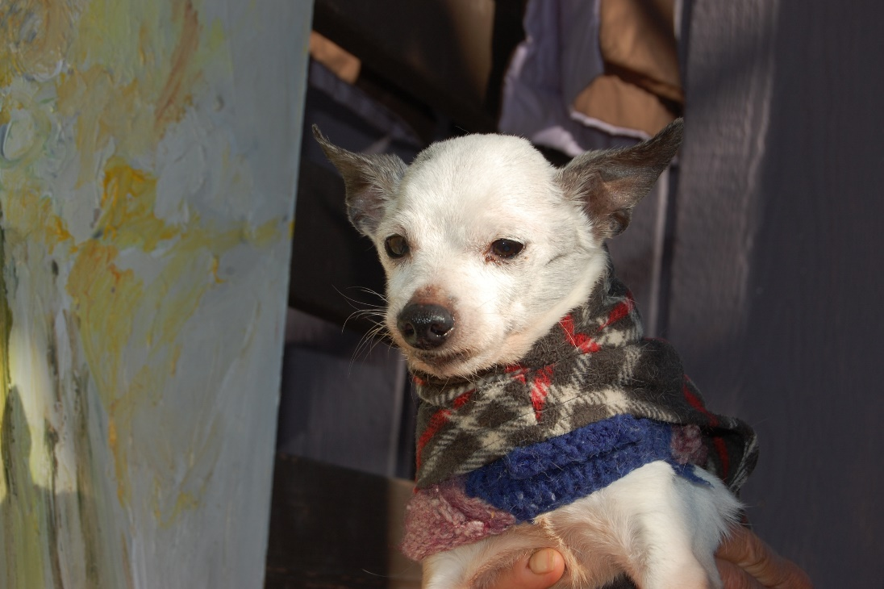
Mater. This sweet old man arrived in Jan 2013 and lived happily just doing his own thing at MCR, relaxing and letting the world go by in a safe environment. Mater was from East Valley LAAS.
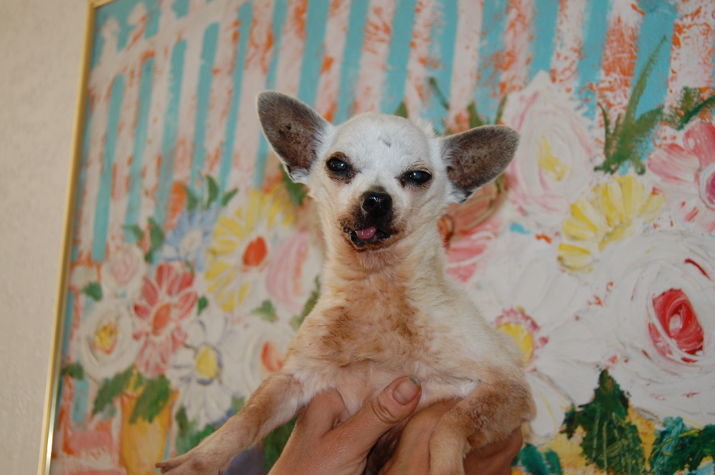
- Simon. Simon came to us just before New Years in 2012, quite the mess from our local SLO pound. Found as a stray, not neutered and with a rotted mouth we fixed the boy up and he ended up fostered with dear Donna. He was so loved and so smart and even in his terrible old condition, Simon never missed a beat.
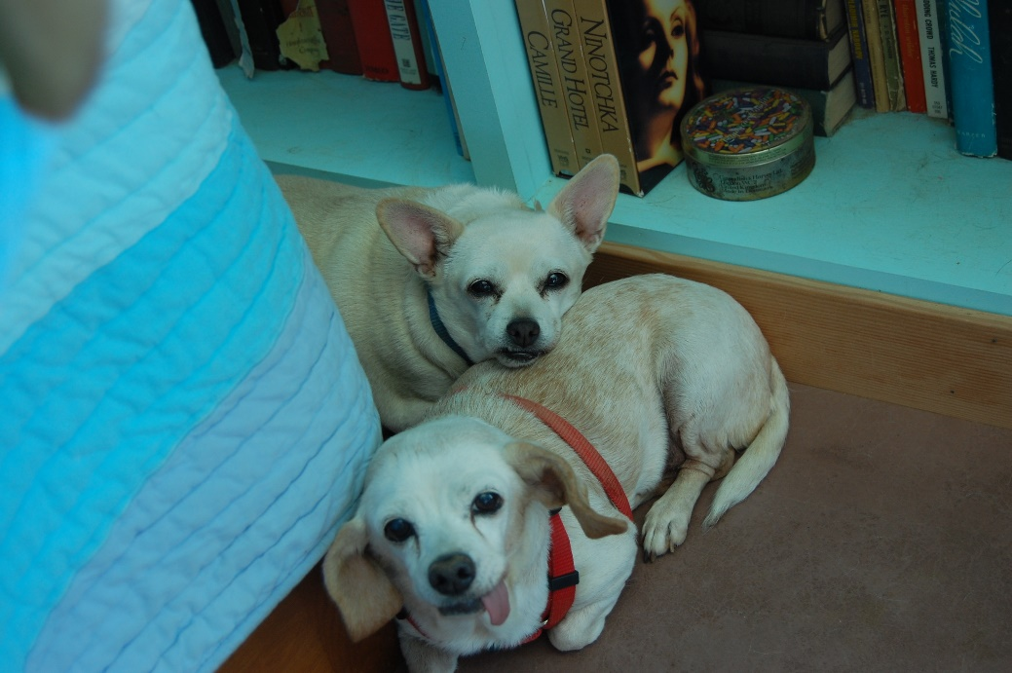
- Muffin & Lilly. Muffin and Lily were a pair from Bakersfield. Muffin was the older of the two and bossed around by Lily, who passed away April 17, 2016. Muffin, was a volunteer favorite and passed away at the vets during surgery Nov 15, 2015 at the age of 16.

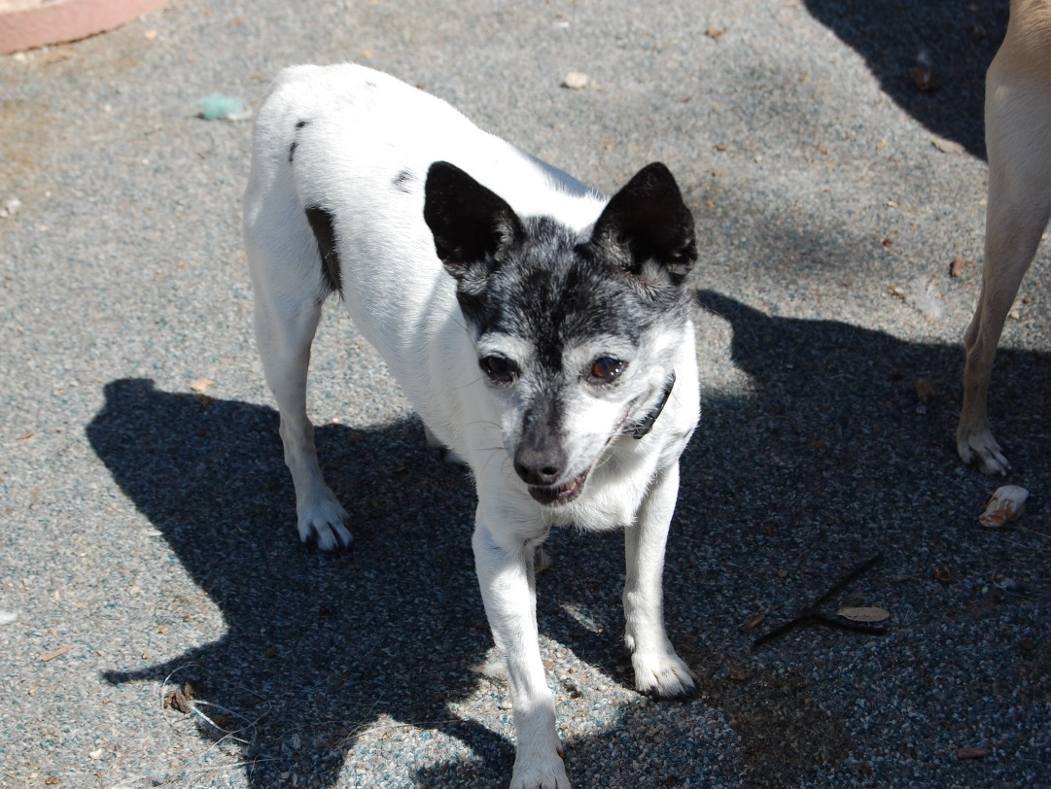
- Mini. Mini the rat terrier came to MCR 3/31/13 from a home that didn't want to keep her any longer. New dog, goodbye old dog. Mini was adopted by a wonderful couple who has adopted several seniors from MCR. Mini died 5/20/16 after an amazing life.
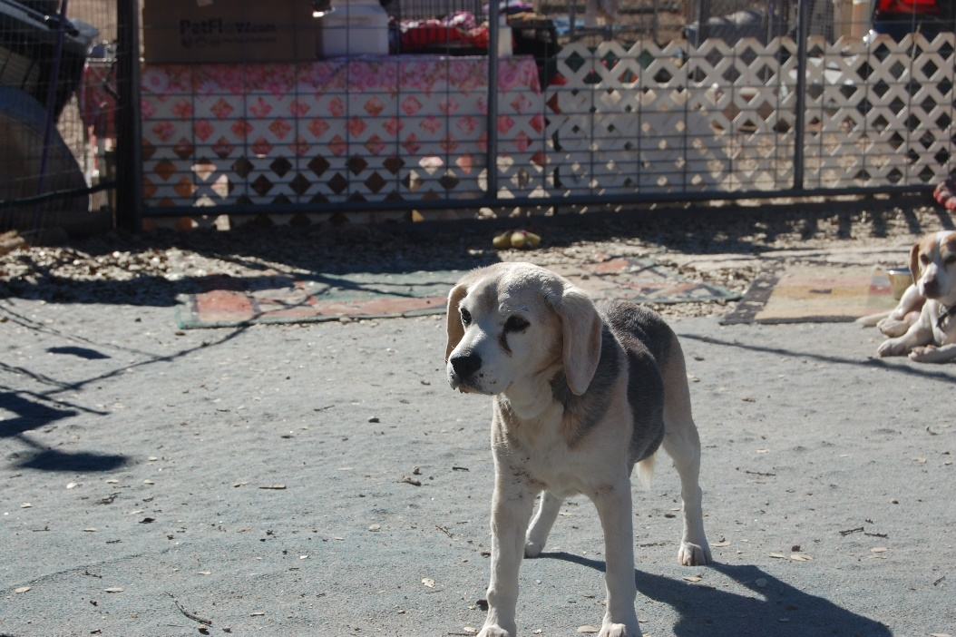
- Meeko. Meeko was a senile, incontinent Beagle whose family was spread out and could no longer keep him. So, he boarded a plane from Chicago and came to MCR. He was 17 when he died after quite a long rest at the rescue.

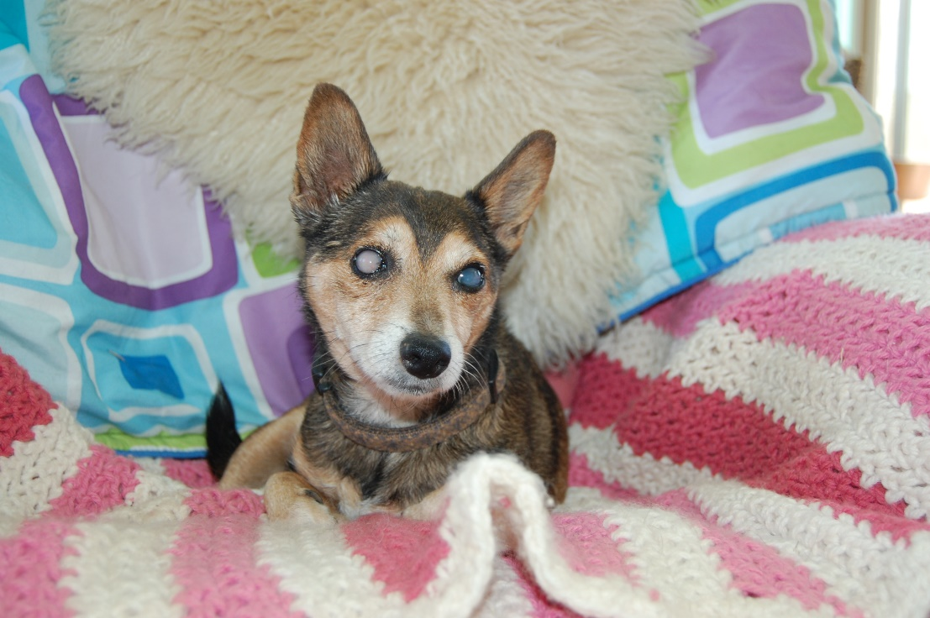
- Gigi. Gigi came to us locally and was fostered until she passed away peacefully at a very old age. She was blind and quiet and kept to herself but even at a ripe old age, she loved to do happy dances when her foster got home from work

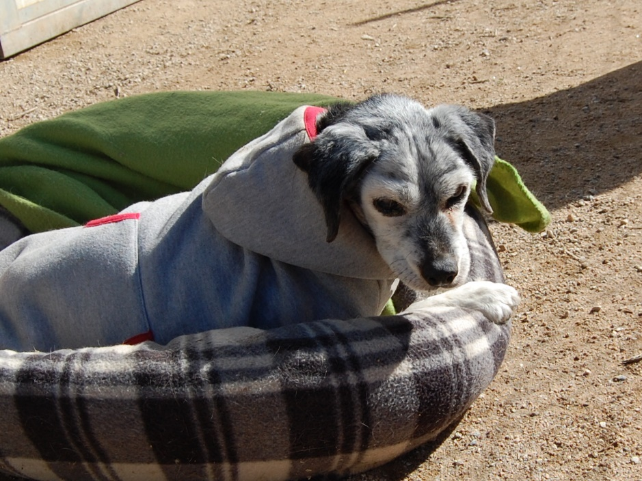
9). Oreo. Oreo arrived in January of 2013 from Lancaster and only lived until April. She has a terribly infected mouth that was surgically treated but she never quite recovered. Thin and tired, we hope she was happy for the time she had here.

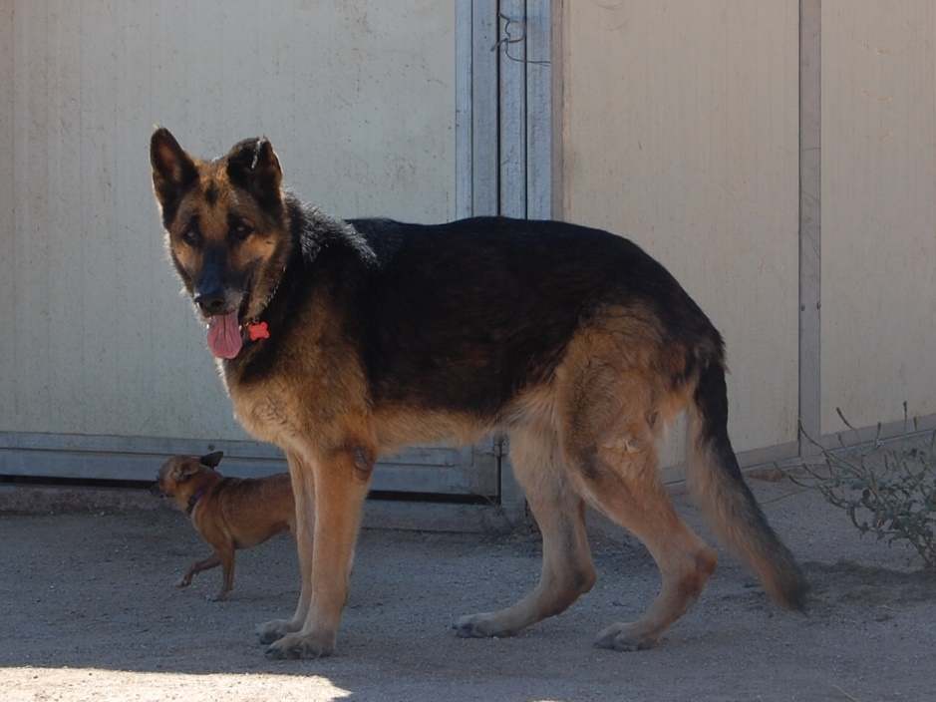
- Girl. Girl came to MCR from LAAS North Central shelter Oct 15, 2012 and at 100 pounds was a big girl. After a run in with a pit bull, we kept her separate and she was a loyal and loving dog, true to her breed.

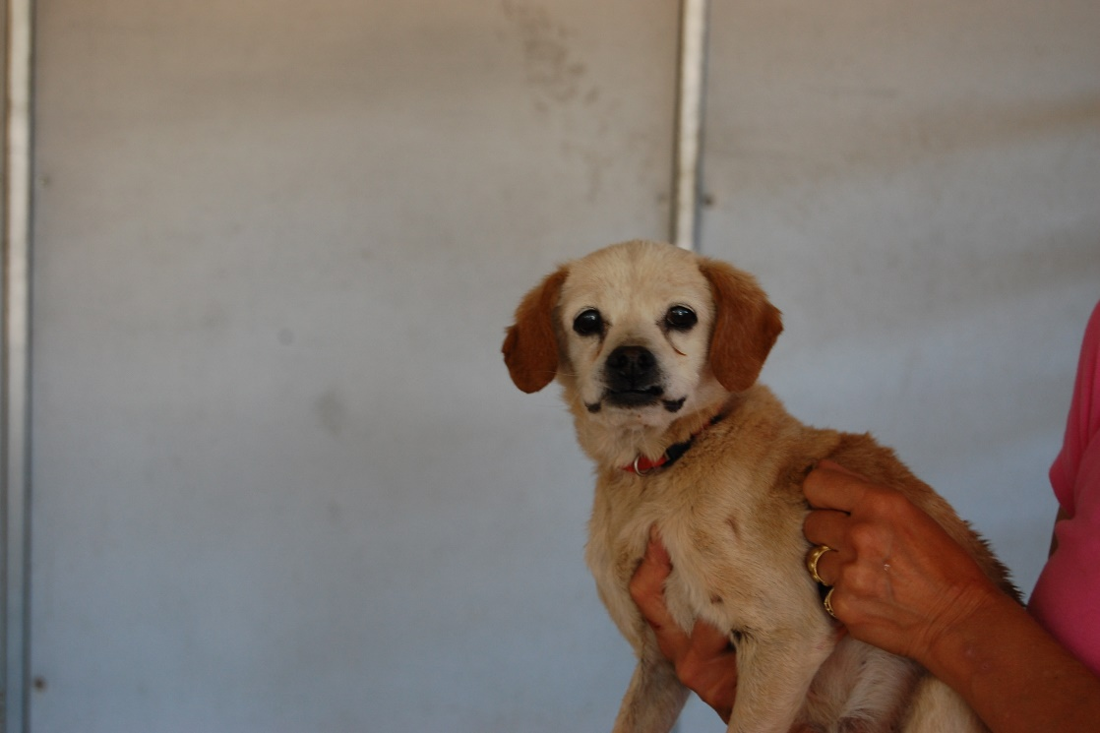
- Bunny. Bunny arrived at MCR in July 2012 in pretty rough shape. Emaciated and in need of love, that is what she got until she passed away at the ranch. She was from WValley LAAS in Chatsworth.

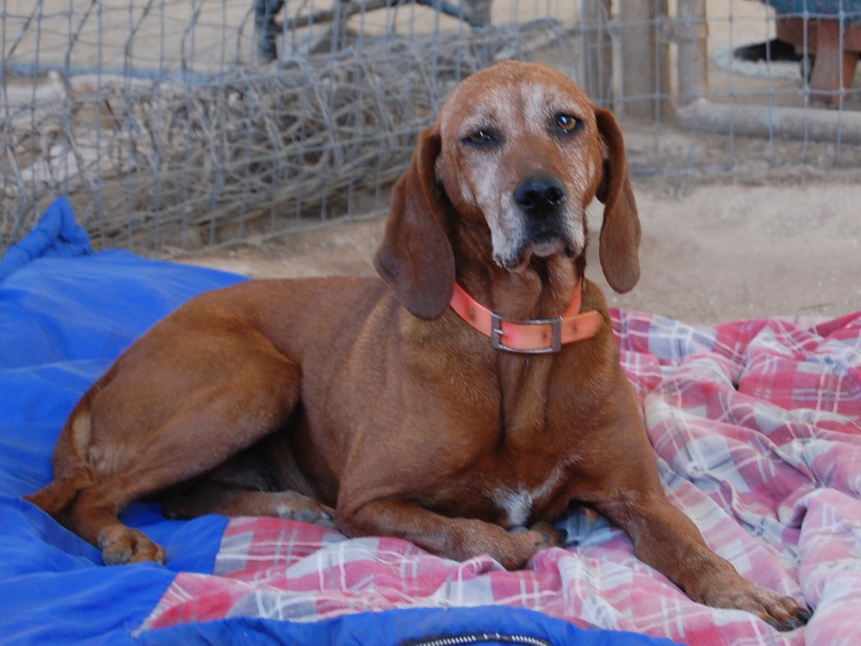
- Reba. Reba was a great dog who loved to run and per her old owners in Shandon, loved to hunt bear. Reba was adopted and we hope to hear an update on this sweet gal. She may indeed still be alive.
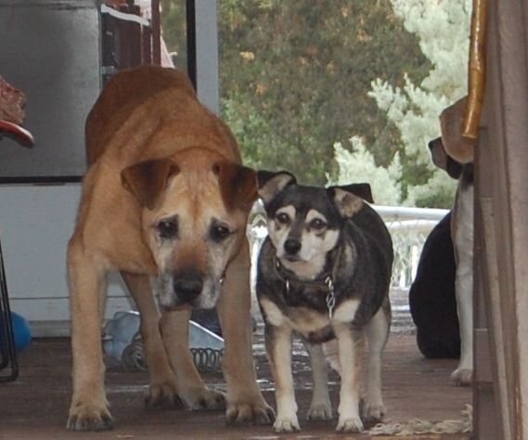
- Peter & Tinker. When MCR moved the sanctuary to CA we traveled across country with 15 dogs who had not been adopted and two of those were old Peter, stubborn as could be and found in a cemetary in Staten Island. Tinker was a CT dog pound dog and though she was feral like she was certainly a favorite.

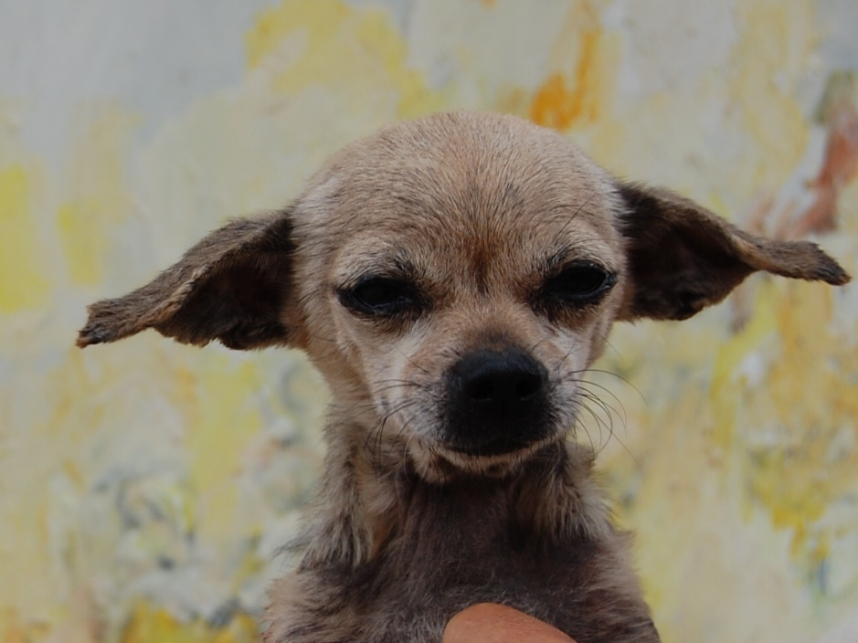
- Alice. Alice was from our police friend in East Valley and arrived at the rescue in 2012. She loved to run in circles with happiness and it was a very sad day when we lost Alice.

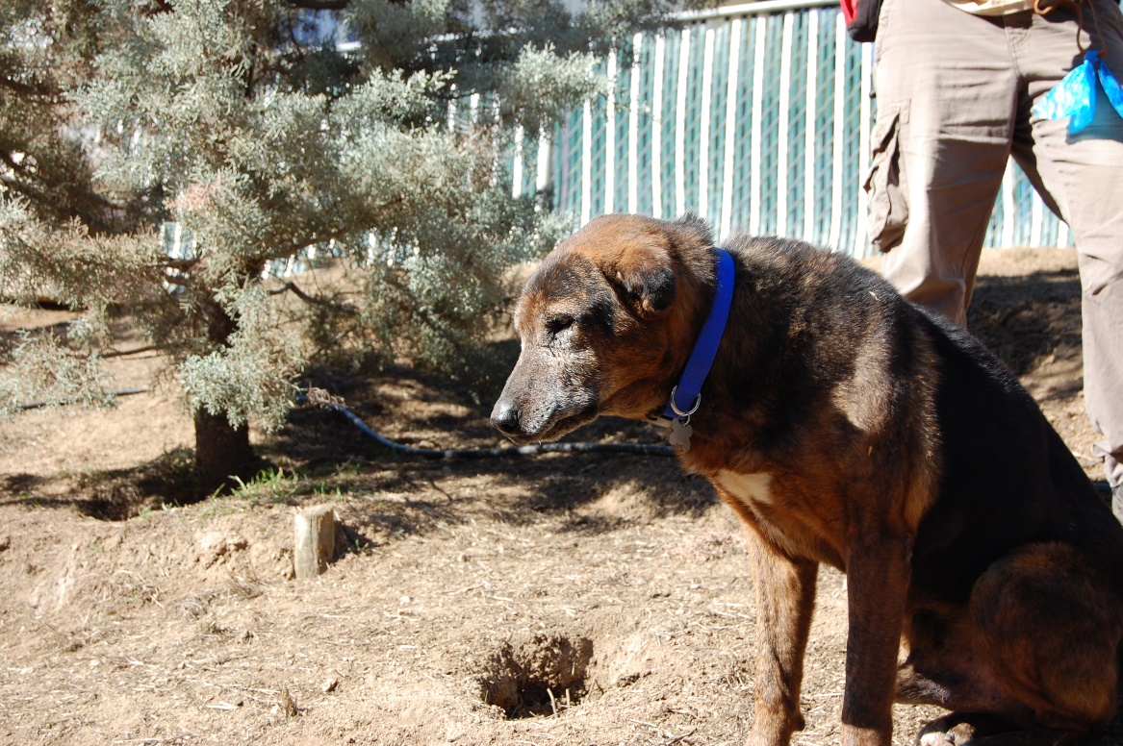
- Jer Bear. Gnarly old Jer Bear from Santa Clarita was a cranky old man, dominant over his gal friend but sweet as pie to humans as he lived his life out saying, "I prefer to be left alone". It wasn't until later in his time here that Jer Bear decided to warm up to the place and relax.

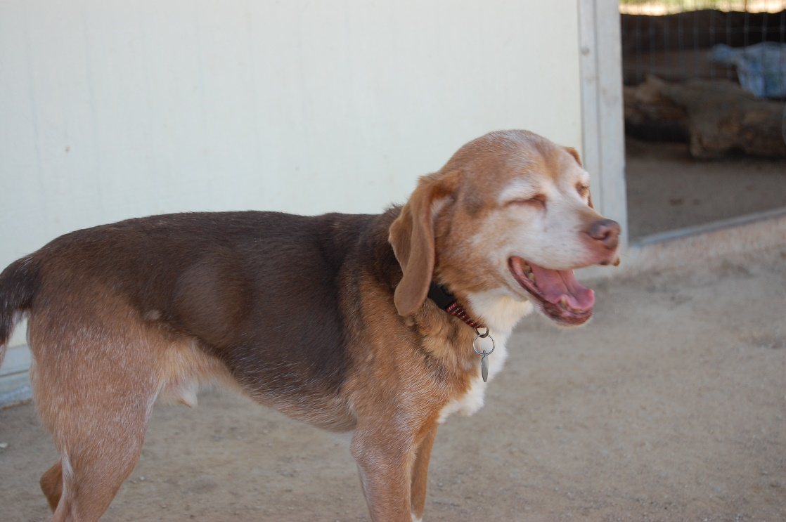
- Gonzo. Gonzo came with Mini and like Mini was a very old boy when he arrived. He was an owner surrender and had been debarked and it was painful to watch this little man make his way in the new world of rescue. He died not too long after he arrived and seemed to remain depressed and wondering what hit him late in life.
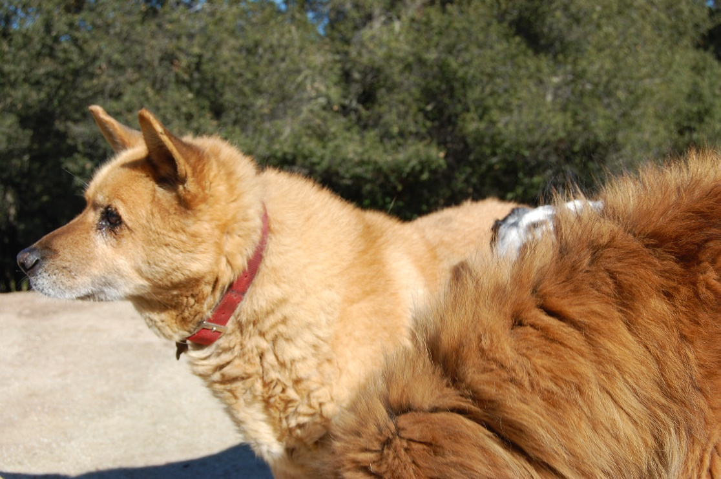
- Golden. Old and getting tired, Golden was a good girl who we were glad to take in.

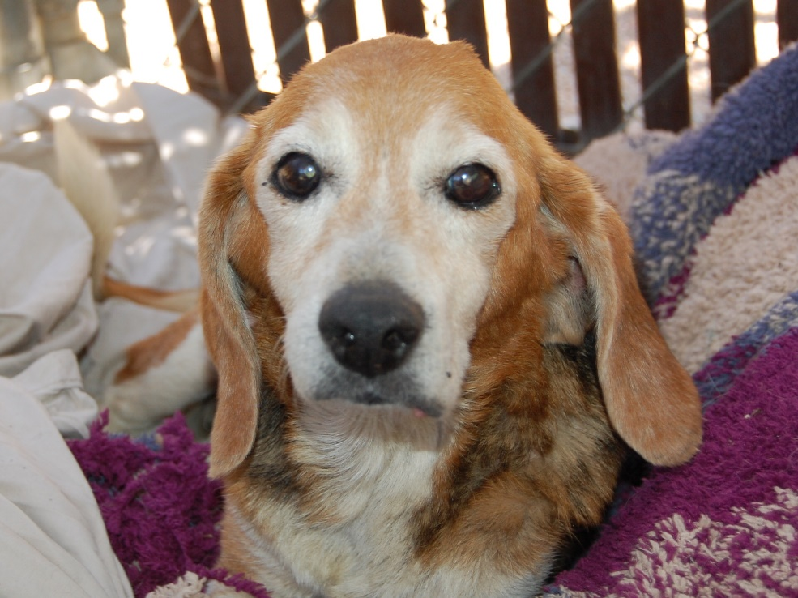
- Gertrude. Challenged and old as the hills, Gertrude lived a true hospice life at MCR.

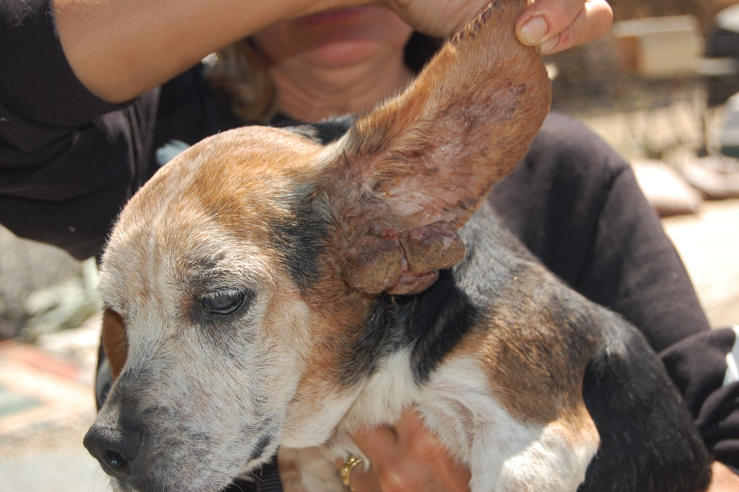
- Georgie. Georgie came to us from Baldwin Park in very bad shape and lived a short time, loved by his puller and transporter, Leela. Poor sweet old boy.

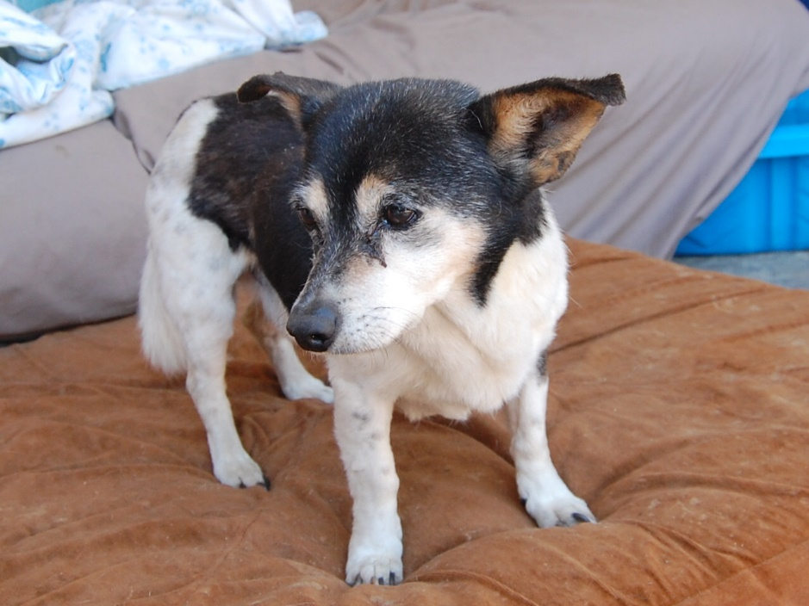

- Clarence. From E Valley Clarence lived at the rescue from May 2012 to his death in January 2013. He lived with foster Donna and was a very sweet boy.

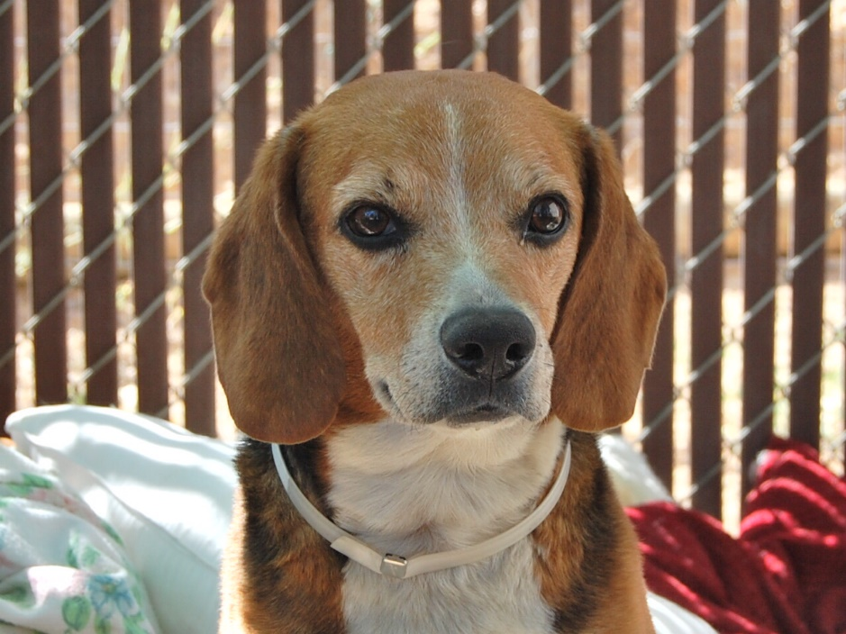

- Baxter. Baxter wasn't the friendliest of dogs and remained a biter but we left him to his own devices which is what a sanctuary does and why dogs can live well here who have no other options.

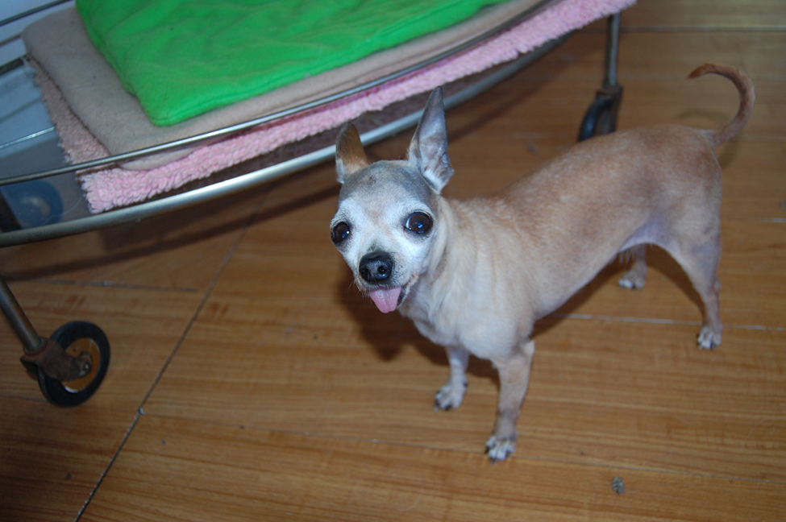
- Sydney. Sydney was tiny but had a HUGE personality and was hard to not just adore and get a kick out of. She was feisty and funny and oh so cute and she lived a great life here from her arrival from the Harbor shelter in May 2014 until her peaceful demise in February of 2016.

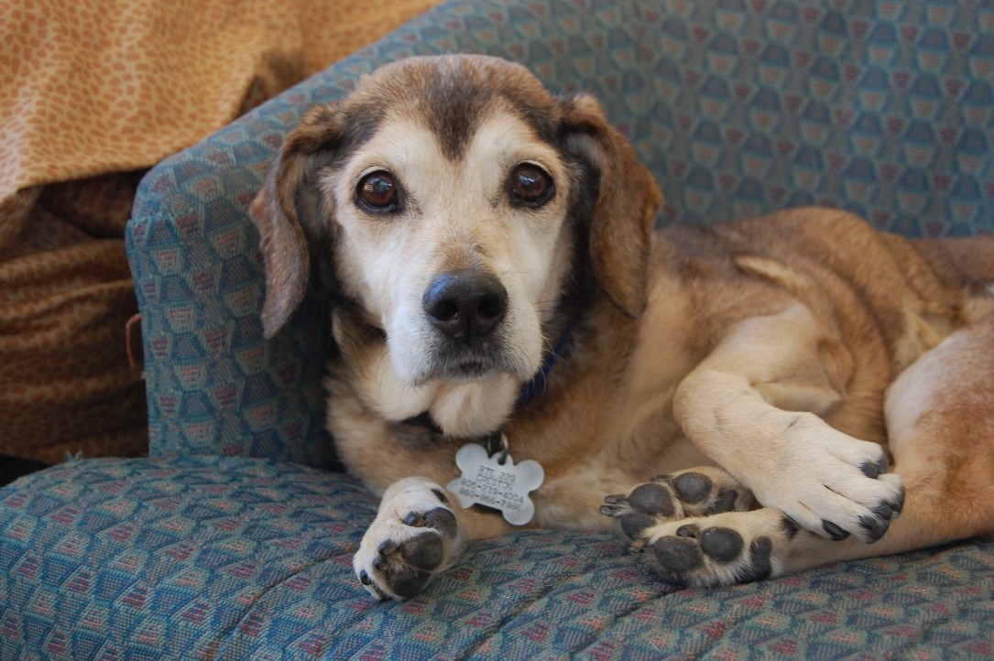
- Paula. Paula was another LA reject, old and tired and deaf and lived her days here, unbothered and happy. She just wanted to be left alone and sleep and be protected.

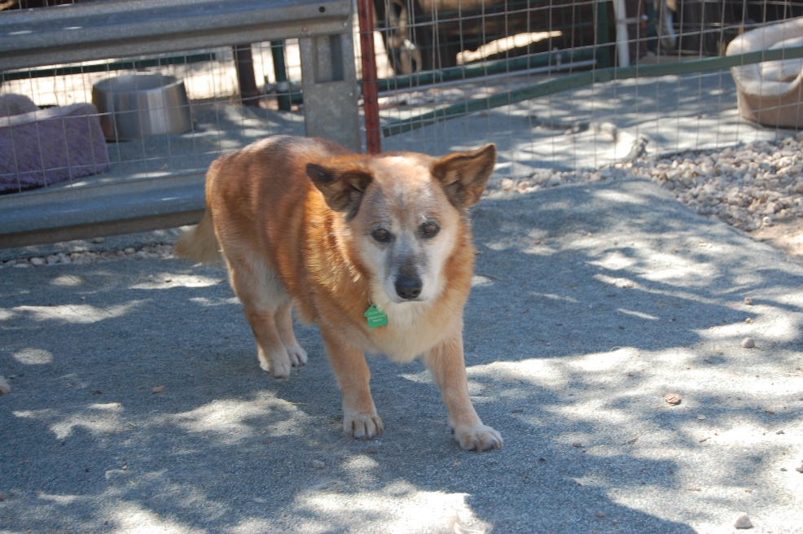
- Barney. Barney arrived from Orange County ACC in May 2013 and passed away JUne 22, 2015. He was grumpy enough but was loved by everyone as he toodle doodled his way through the rescue.

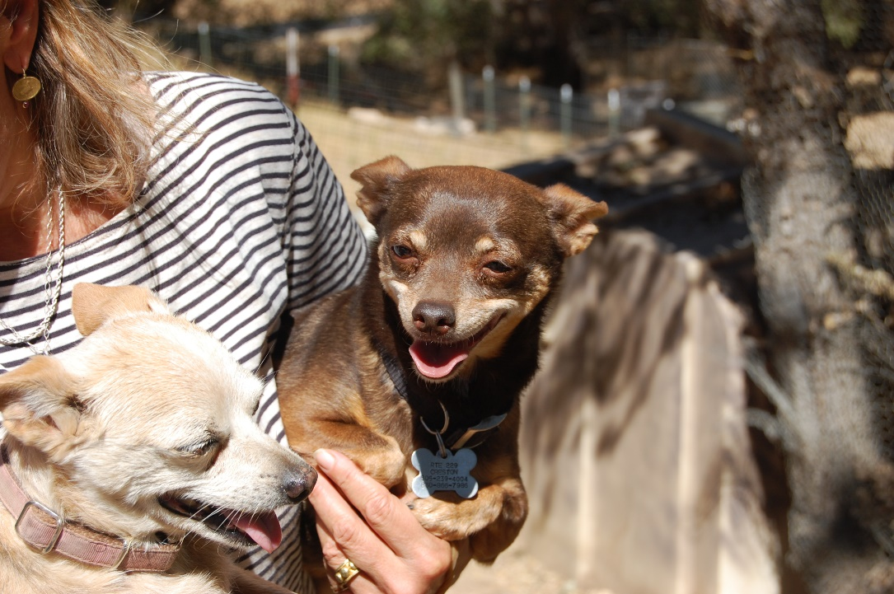

- Caramel. A dog who is one of so many who get overlooked at dog pounds. This dog was from a hoarding situation and came with several others.

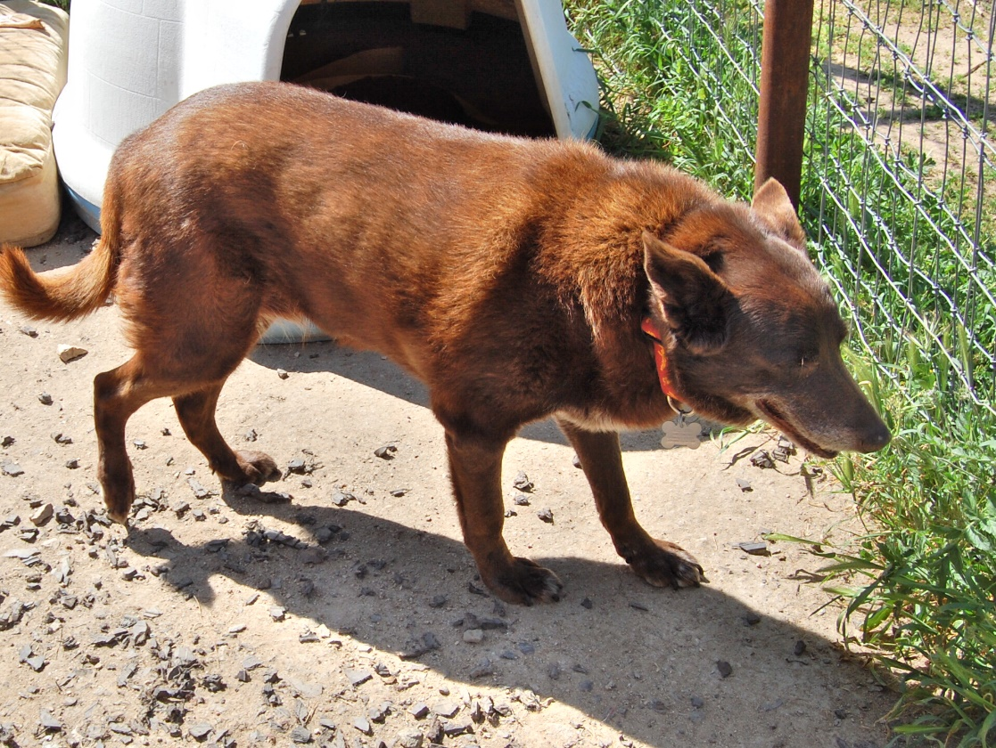
- Hershey was a sweet old chocolate Lab who came to MCR from Corona and passed away from bladder cancer in 2013 not long after arriving. Her time was peaceful and she was content to just do her own thing, loved by everyone here.
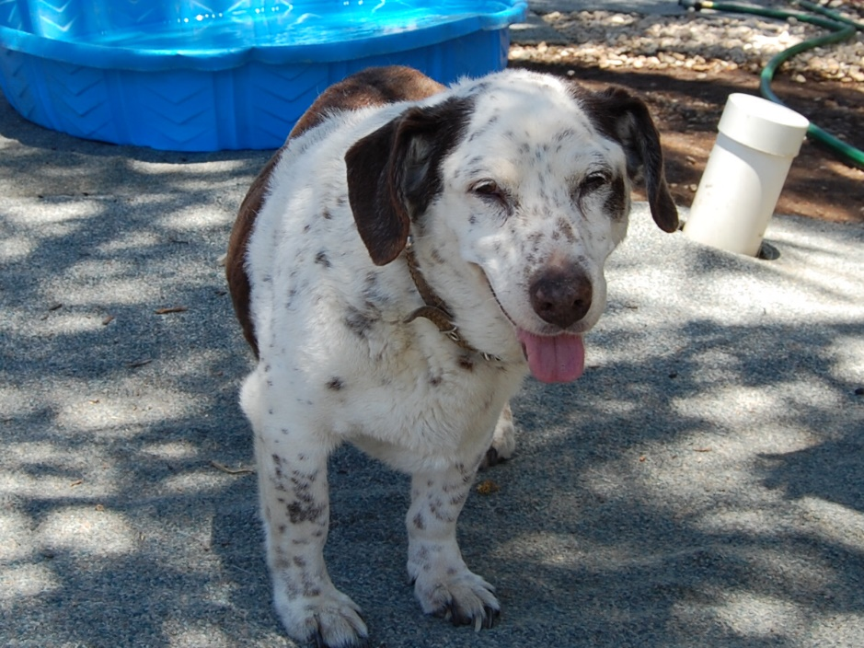

- Henry nipped at the ripe old age of 15 and his owners turned him into WLA animal services. Low to the ground and beautiful he could be anything he wanted here at MCR. He lived 18 wonderful months and had quite a following.

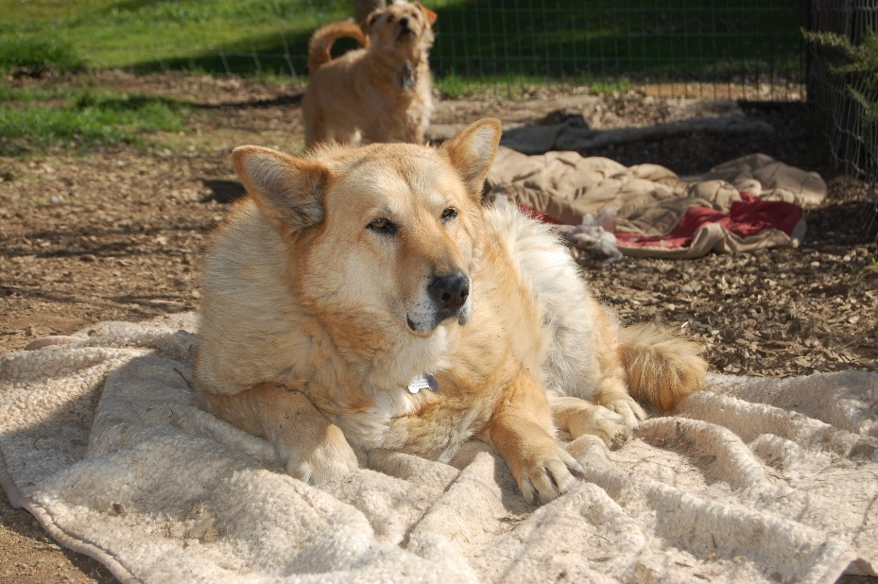

- Our 'driveway dog' Miss Hanalei was turned into SLO AS Christmas Day 2012 and watched over MCR for 3 long years. She greeted everyone who arrived and tried her best to avoid Chihuahuas!

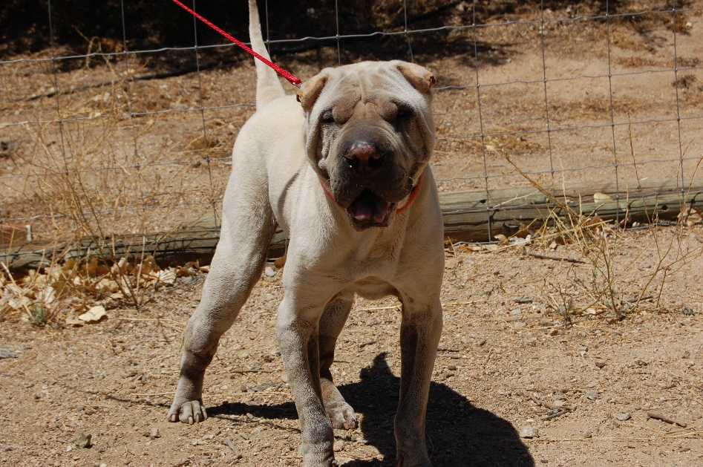

- Hemingway's owners gave him up and he sure did miss them but finally realized they were not coming back and lived at MCR til the ripe old age of 13.

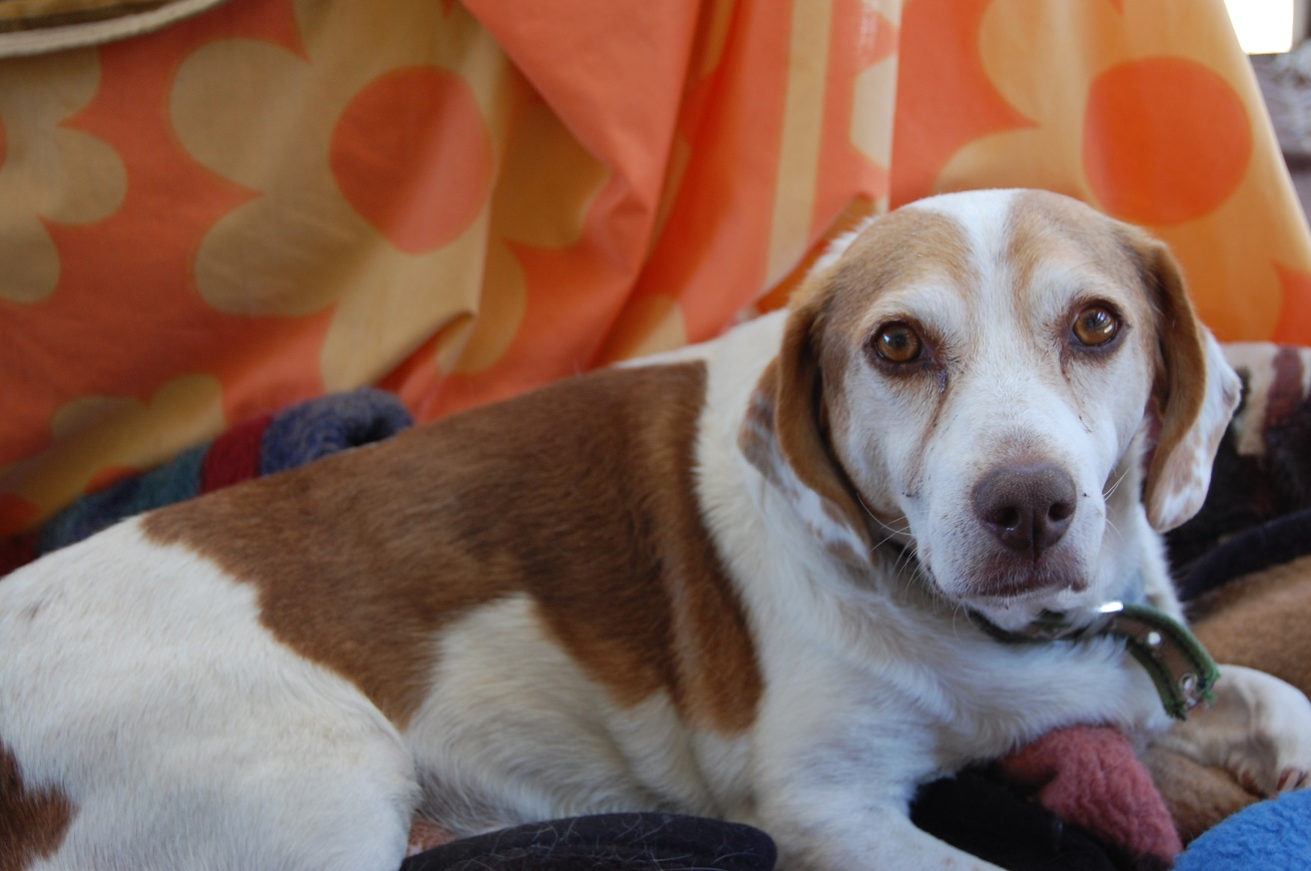

- Buddy came to MCR from Stockton with all kinds of health issues and some were pretty major. With his twisted front paw he never let it get him down. Only at the end did he tire and prefer transport on the rounds in the wagon. Buddy had the most soulful eyes. Sorely missed.

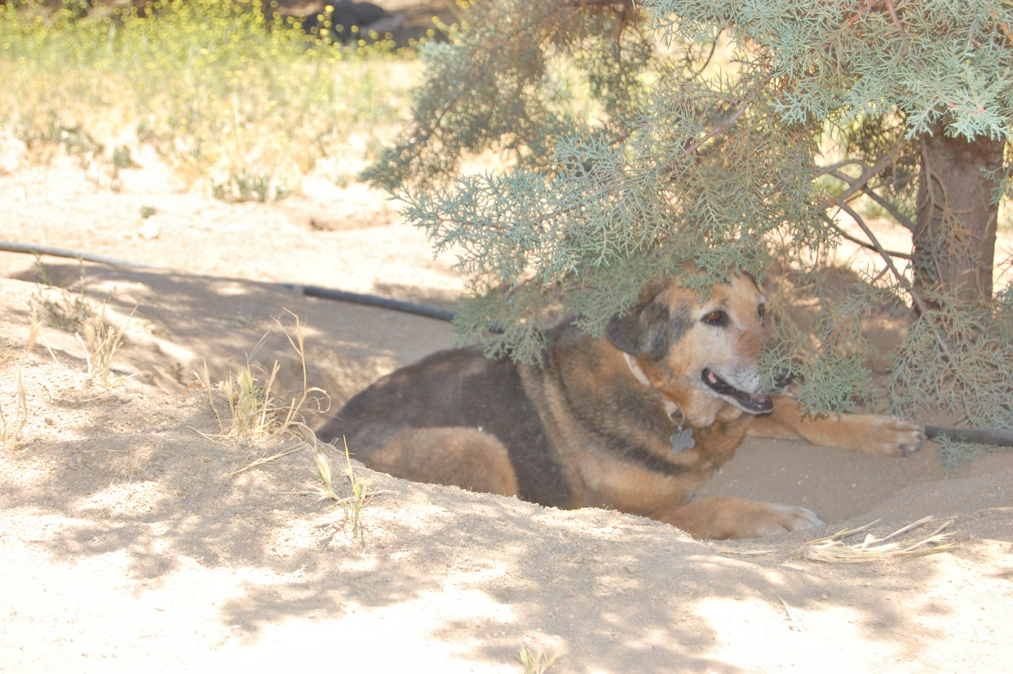

- Bossed about by Jer Bear her whole life, they were a team. Sweet girl who never bothered anyone.
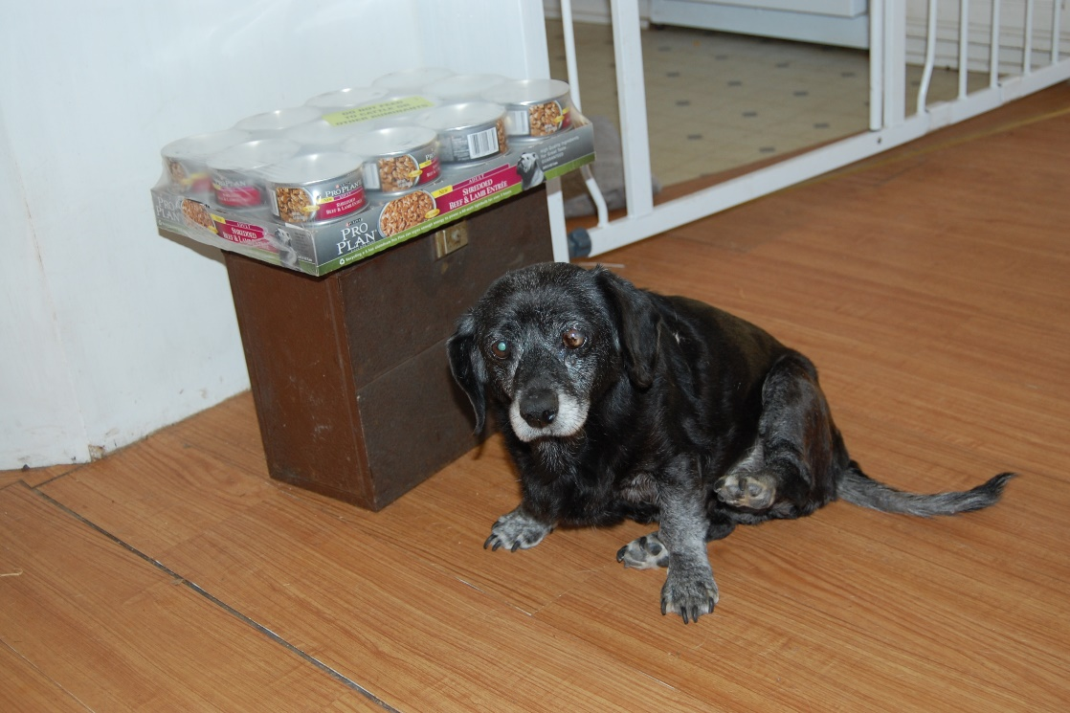
- Our Sacramento County gal who was ancient when she arrived and rested most days. Cute mix and sweet old lady.

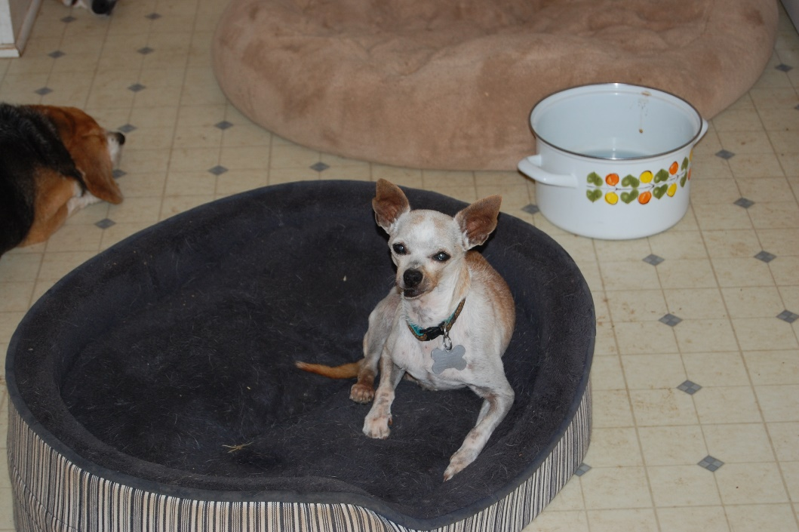

- Another very old Chi mix and volunteer favorite, Gramps was thrown out in Bakersfield and picked up by two special women. Rotted teeth and unneutered when he arrived. What's new? We took him in and treated his issues and loved him dearly.
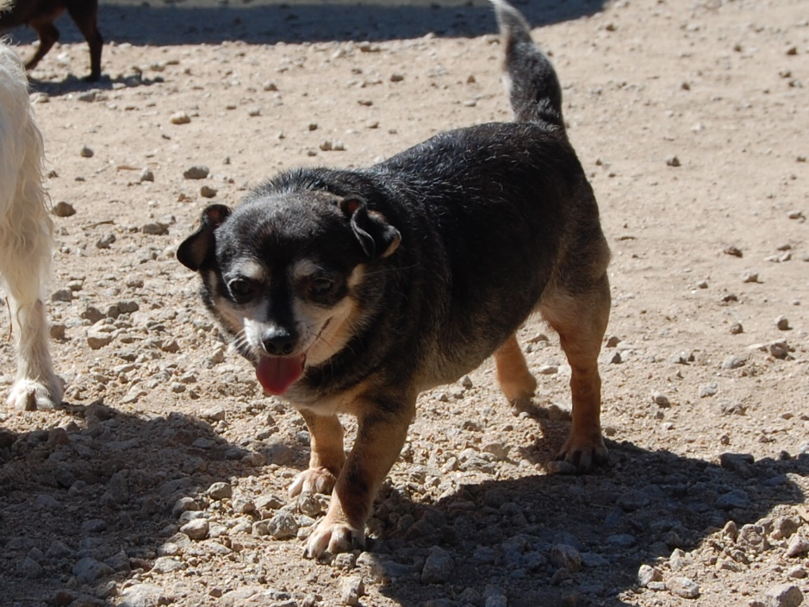

- A happy little guy with a challenged heart and a weight problem, Brady moved to foster where he passed away peacefully after a loving stay.

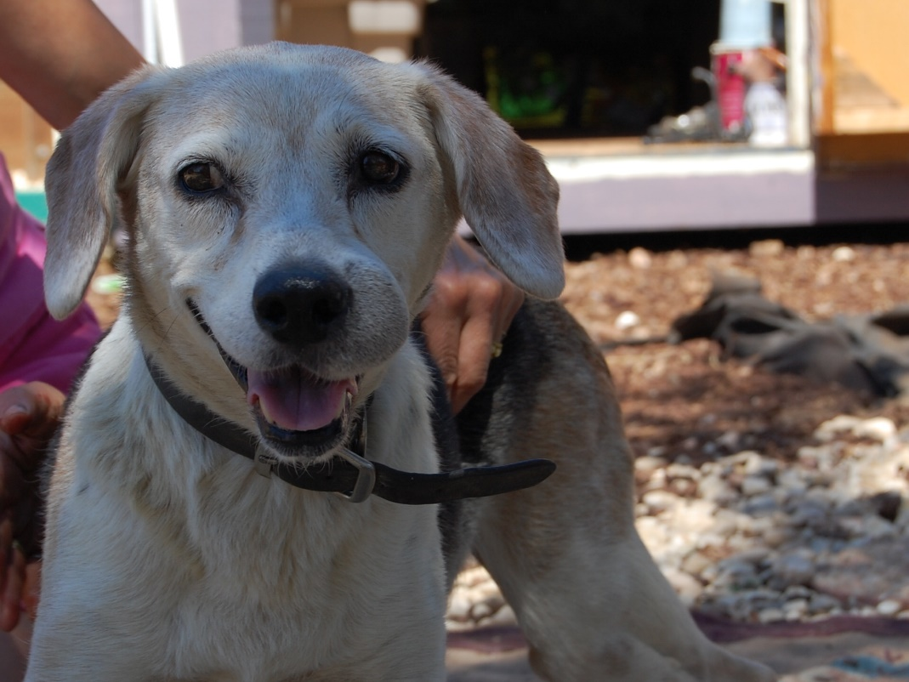
- Rusty was our ranch dog from North Central LA and an amazing guy. He lived for 3 years happily with that endearing lump on his nose. Whoever gave up Rusty let go of an incredible dog. It was a sad day when Rusty died.

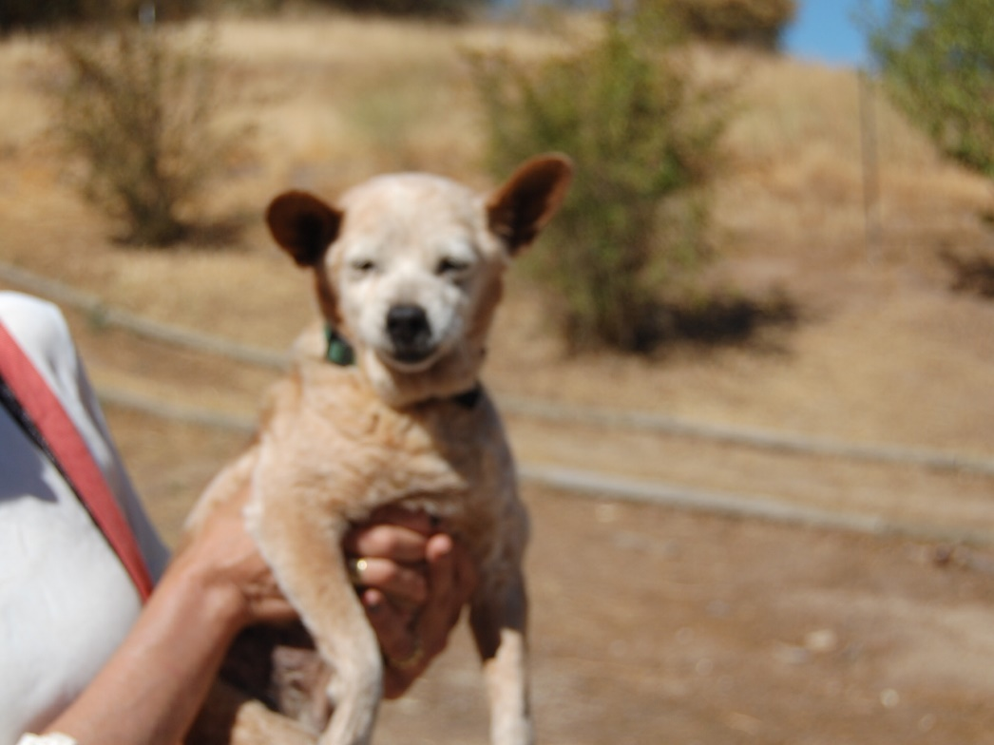

- Found in Paso, thrown out to be sure for being a very old gal, Betty lived at MCR for 6 months before crossing that Rainbow Bridge.

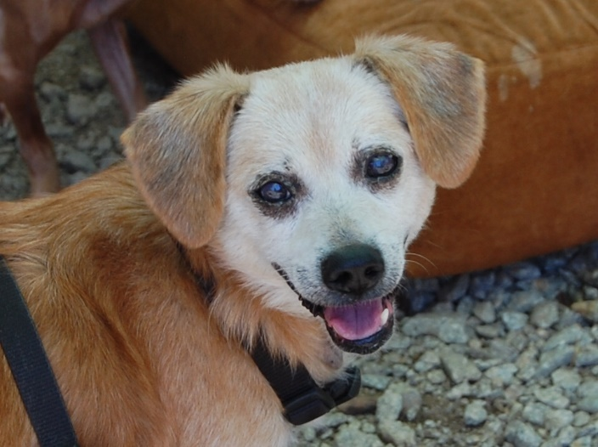
- Sweet Monkey was adopted and returned for growing older. When he had another chance at a home, he died that day, just a day after dental surgery. Very sad for everyone involved.
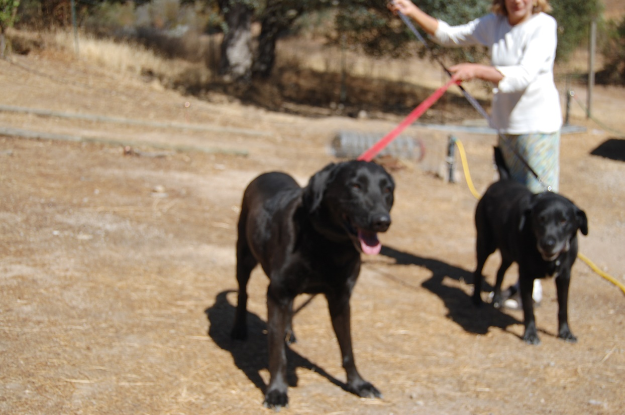
- Belle. Quite the handful from Lancaster! But she had fun at MCR and lived the way she wanted to.

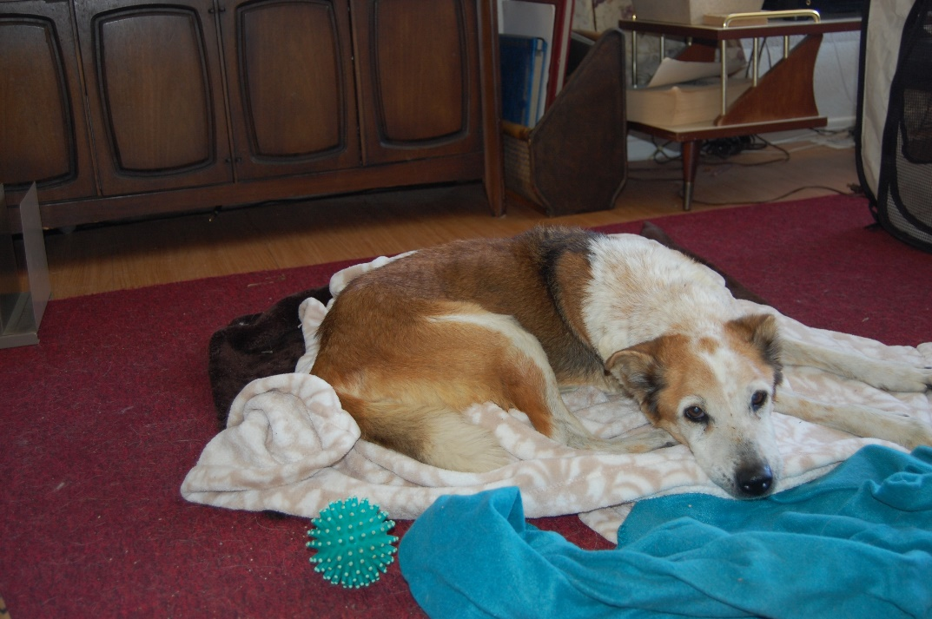
- Adeline was one of the most heartbreaking dogs MCR took in. Emaciated and so weak when she arrived she couldn't stand but she gained strength and weight and put in a run for her money. Everyone who met her was touched. Adeline came to MCR from Kings County AS.

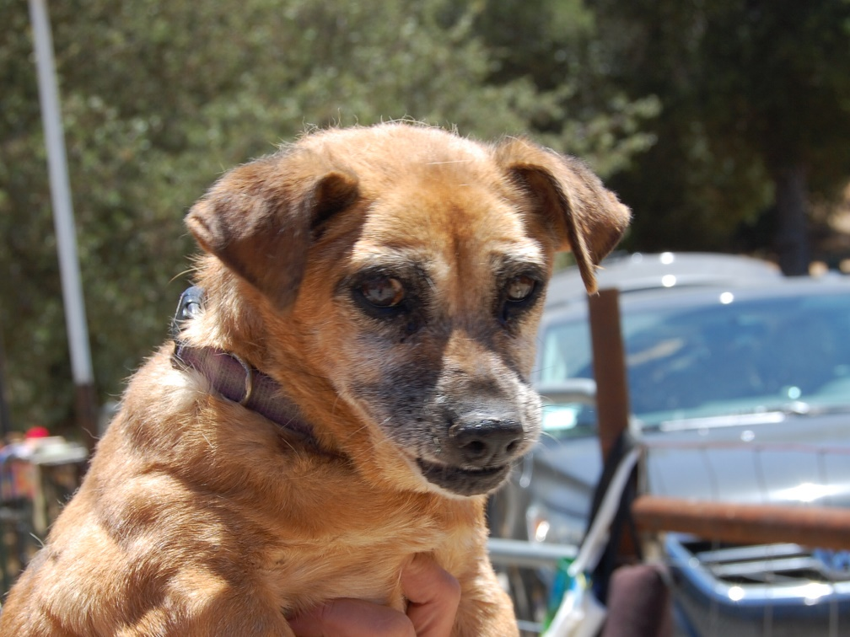

- Rosie from WLA was so very old and so loved. She was with MCR and a foster for one year before old age finally took her from us.
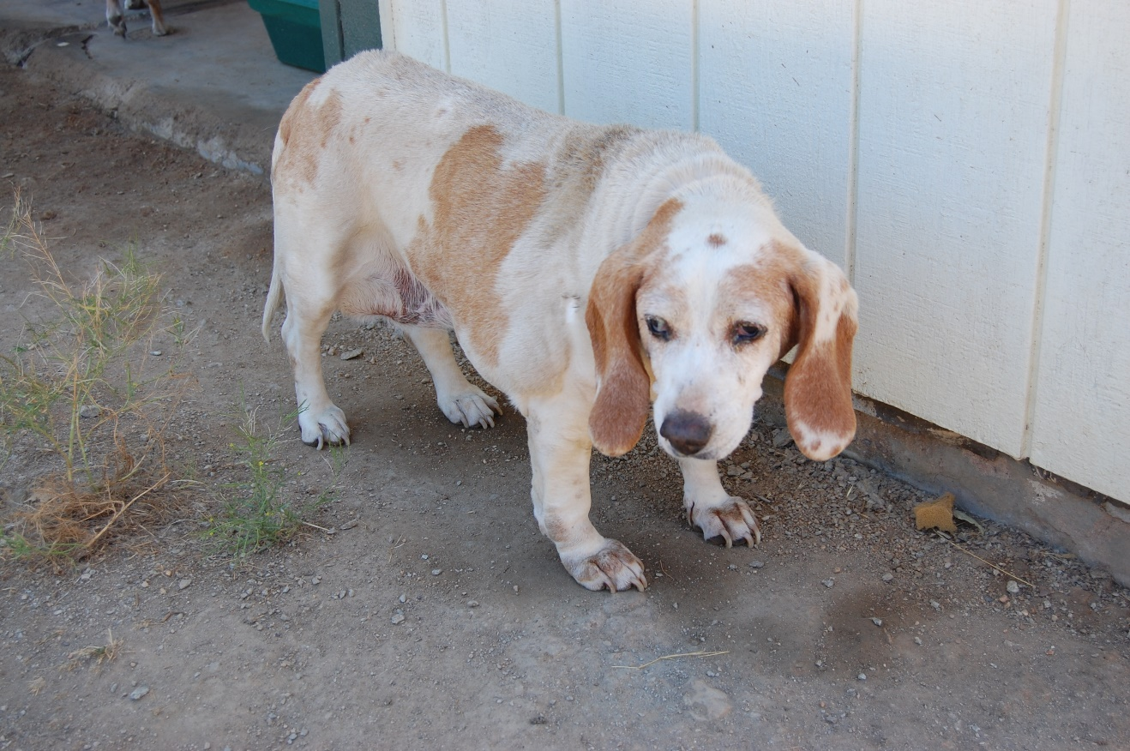
- Dear Emily arrived early on at MCR CA from OC animal services with an enormous inoperable mass. She lived with us for a couple months.

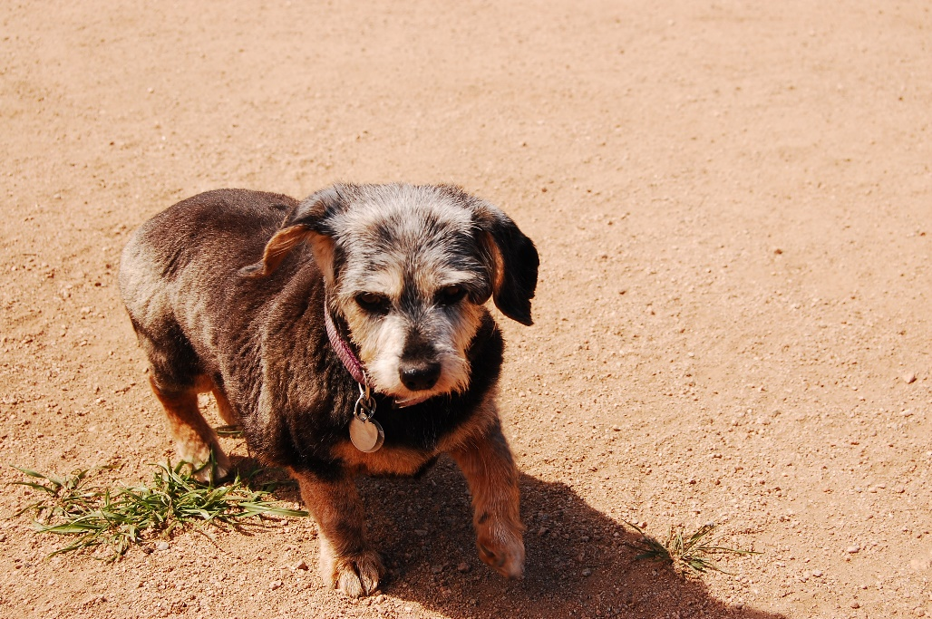
- Xena kept to herself and we welcomed her.

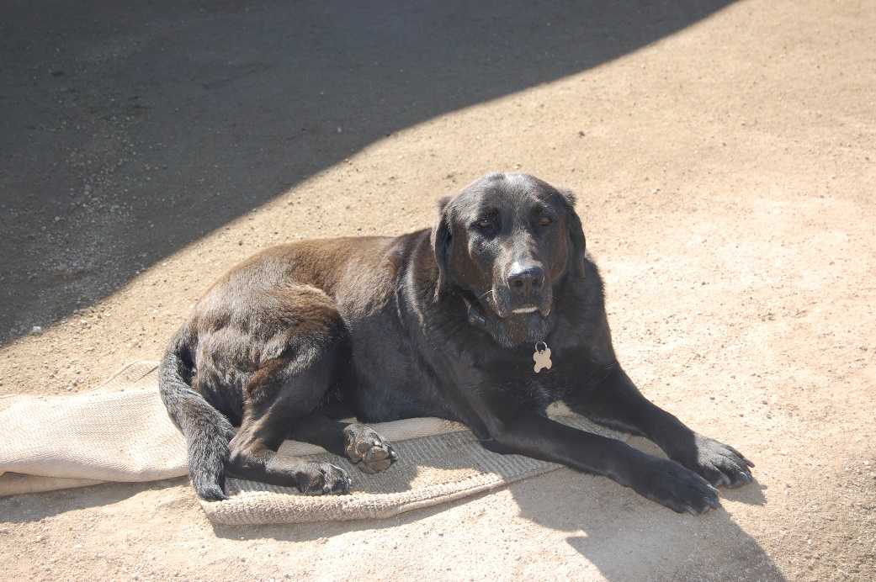
- Daphne from Lancaster lived with Belle at the barn and both were a handful but safe and happy in their time here.

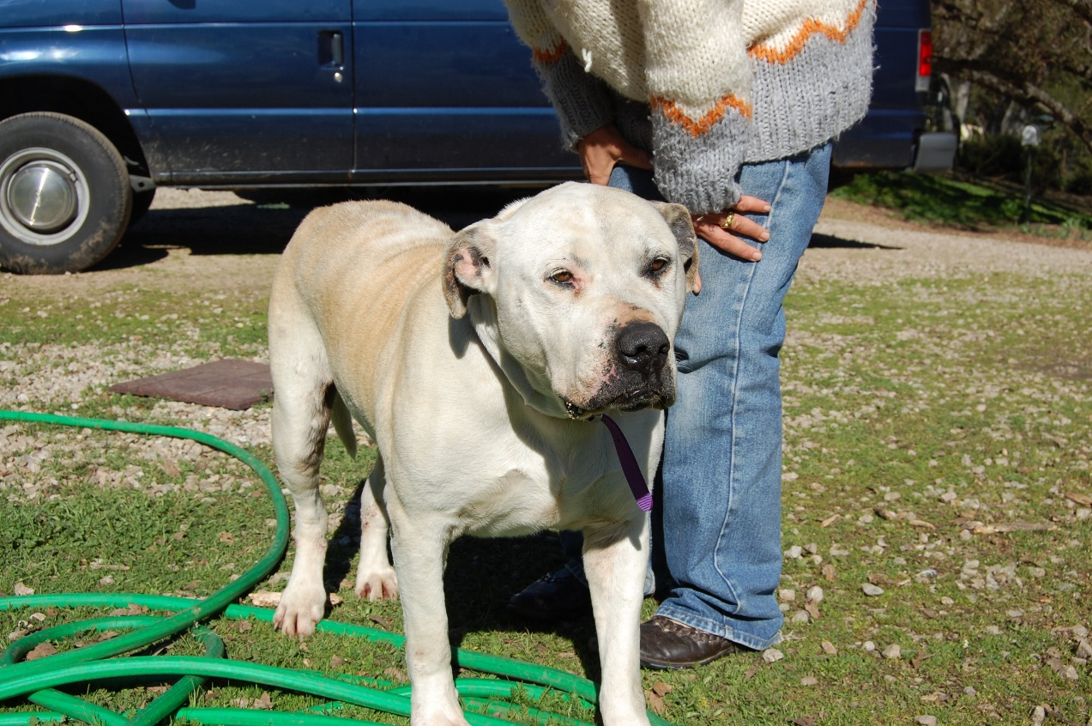
- Pretty was a SLO dog who (though our cats wouldn't agree) was one of the sweetest old bullies ever. She loved to fetch and was a favorite of everyone. Used to breed for too many years of sadness, when she got to MCR those days were over!

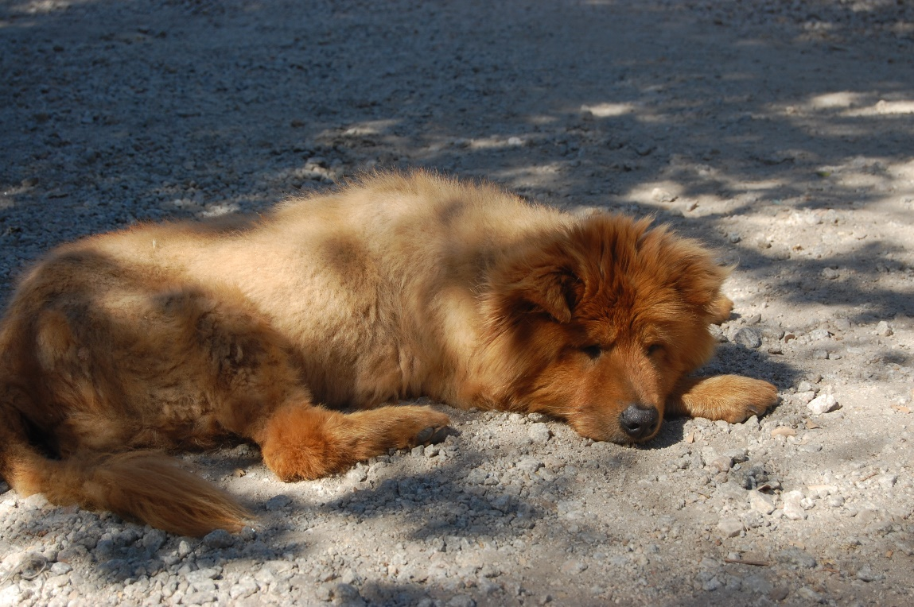
- Paprika was one of the oldest Chows ever! Medically challenged, she needed rest and quiet and that is what MCR provided.

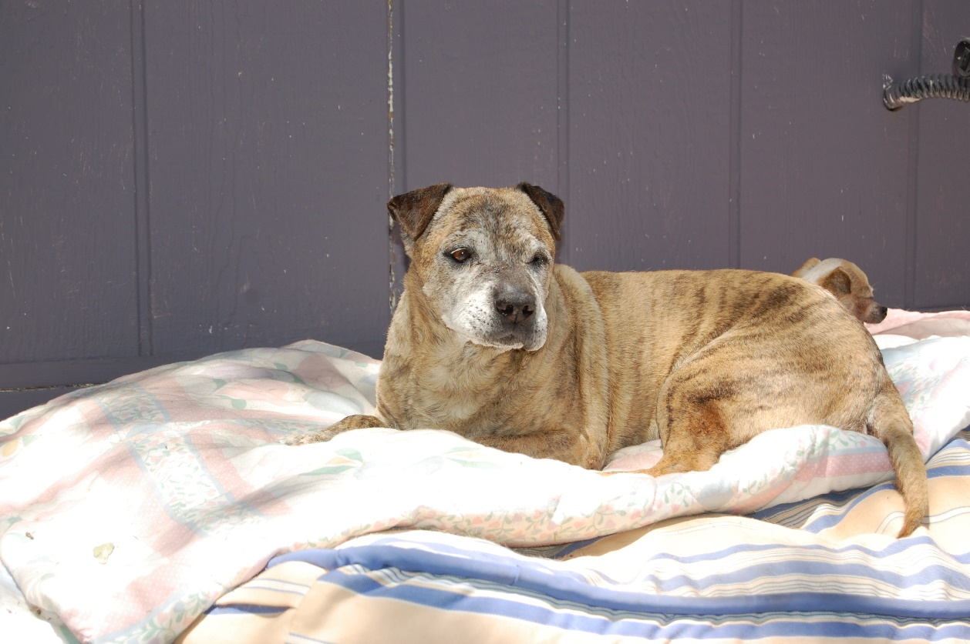

- Leonardo was a toodle doodler if there ever was one and one of the strangest looking mutts ever. He came from E Valley in May 2013 and died just before Christmas 2015. Certainly, one of our oddest little men. Lying in the sun was a favorite past time.

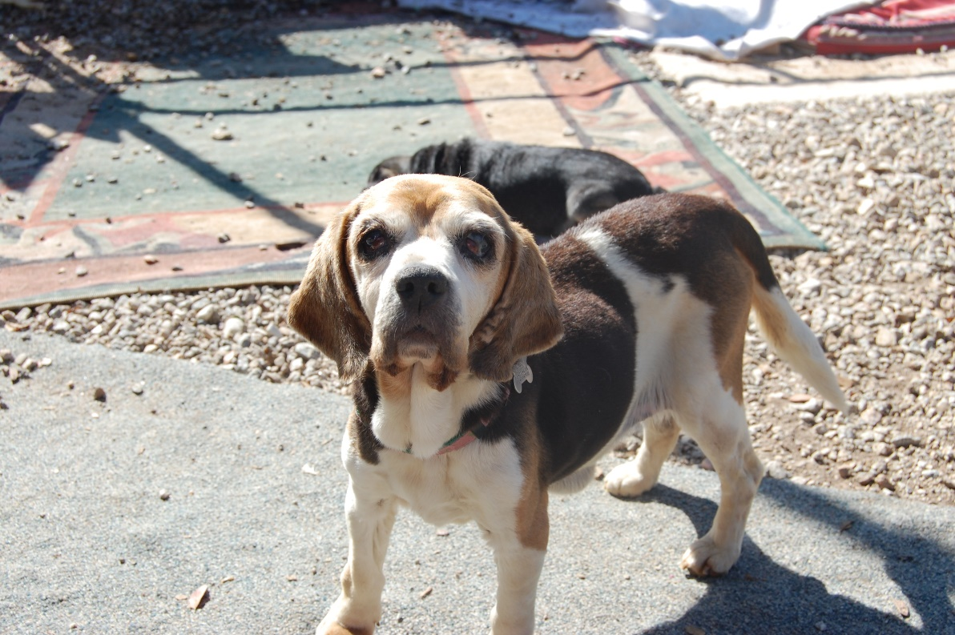
- Mari was another ancient gal who arrived in terrible condition and though she didn't live very long, she was so very loved in those last weeks.

