

South Range Stadium Eagle Project
Fall Brick BLITZ

BUY A BRICK PROGRAM
This is an Eagle Scout project directed by HS Football Senior, Blake Sitch, who is raising funds to install a 50’ flagpole, inscribed bricked patio and benches in the NE corner of the new stadium; which must be completed before the cold weather hits! There is a very limited time to secure your purchase and forever be a part of this stadium BLITZ phase!
Order your eye popping inscribed message on a “Majestic” color brick to honor any player or sport, a memory, business, club, family, friend, loved one or that you’re the greatest! Hurry and don’t delay, the deadline is October 7, 2016.We reserve the right to reject unacceptable messages.
----------------------------------------------------------------------------------------------------------------------------------------------------
Proceeds above & beyond this project are donated back for additional phases.
TEXT IS CENTERED AND IN CAPS (ANY SYMBOL IS CONSIDERED ONE SPACE ~ PERIOD, COMMA, DASH, ETC.)
~ LIMITED TO 3 LINES, 18 CHARATERS PER LINE PER BRICK AS SHOWN.

4 x 8 ~ Brick #1 = $85.00

4 x 8 ~ Brick #2 * If buying a 2nd brick ~ both for $160.00. If not ordering a 2nd brick, put a line through each row.

EXAMPLE:
S | O | U | T | H |  | R | A | N | G | E |  | S | P | O | R | T | S
B | E | S | T |  | O | F |  | T | H | E |  | L | A | S | T | !
I | T | C | L |  | C | L | A | S | S |  | O | F |  | 2 | 0 | 1 | 7

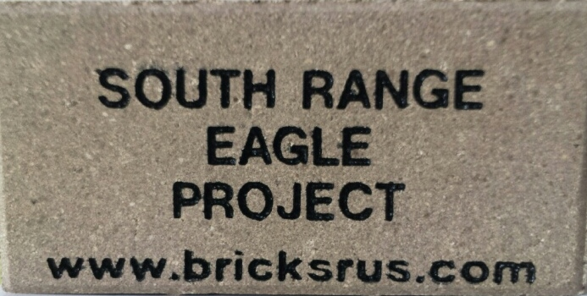
PLEASE RETURN THIS FORM AND YOUR CHECK PAYABLE TO:

BSA Troop 80 – SR Eagle Project
PO BOX 64
North Lima, OH 44452

Name: __________________________________________ Phone: (_______) __________________________
Address: __________________________________________________________________________________
City: ______________________________________ State: ________ Zip: __________
Email Address: ______________________________________________ Amount Paid: ___________________

FORMS AND PAYMENT MUST BE RECEIVED NO LATER THAN October 7th 2016.
If you have any questions, please call (330) 717-9033.

YOU MAY ALSO ORDER BRICKS, REPLICA BRICKS, HONOREE CERTIFICATES & ADD LOGOS ON OUR ON-LINE ORDERING WEBSITE: WWW.BRICKSRUS.COM/ORDER/SREAGLE
Visa, MasterCard & American Express accepted.
Eagle Scout Project Supported Through Troop 80 Greenford / North Lima

